7am – 7pm
JUDGE ROOM
2x 8x30” tables
20x chairs
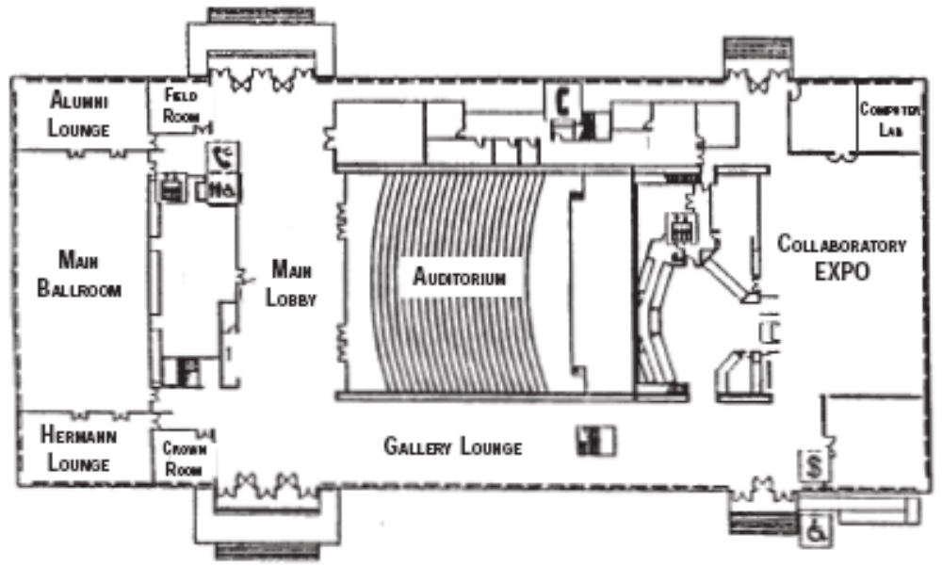
7am – 7pm
VOLUNTEER/ISB ROOM
LCD Projector
Projector Screen
2x 8x30” tables
30x chairs

7am-7pm
OPENING/RESEARCH
Sound system
Projection screen
Stage lights
Microphone, fixed lectern

7am-7pm
COAT CHECK
Coat racks

7am-7pm
POSTERS
Easels
7am-7pm
LUNCH/GRAD/MED
10x 6’ tables
10x chairs
7am-7pm
BANQUET PREP

7am-7pm
REGISTRATION
3x Reg. Table
6x chairs
6x round tables w/ skirts, chairs
3x 8’ tables
4:30pm-8pm
BANQUET
Round tables for 150
4xStage (6x8)
Stage stairs
Lectern
Projection screen
LCD projector
Sound system

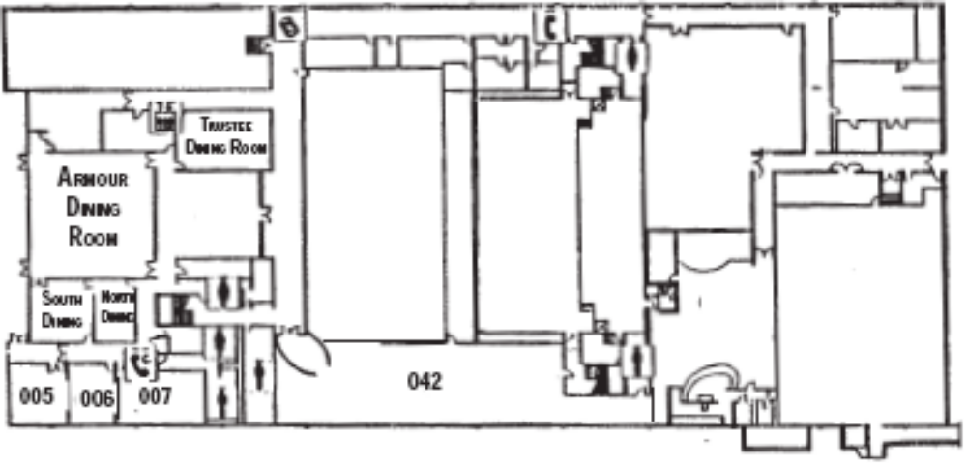
7am-7pm
ORAL
LCD Projector
Projector Screen
100x chairs

7am-7pm
ORAL
LCD Projector
Projector Screen
50x chairs

7am – 7pm
ORAL
LCD Projector
Projector Screen
50x chairs

7am – 7pm
ORAL
LCD Projector
Projector Screen
30x chairs

